HW5_1

 

Method 1

1. 先將Force除上面積A得到stress, deformation除上厚度t得到strain, 之後找出最大值將stress及strain正規化

2. 接著找出兩曲線峰值座標差Δt, 又ω = 2πf, 得到δ = ω Δt

3. , ,



Method 2

1. 將stress對strain作圖, 得到橢圓的圖形

2. 找出最大strain的位置, 與原點連線即G’

3. 與y軸交點為 $G^{''}γ_{0}$,所以除上最大strain $γ_{0}$, 即是G’’

4. $η=\frac{G^{''}}{G'}$



Discuss



1. 7.5mm G’ and G’’ smaller than 2.5mm.
2. 7.5mm stress-strain area is larger.
3. 7.5mm strain is larger, so stiffness is smaller.

import numpy as np

def get_data_by_excel(*ws*, *min_row*, *min_col*, *max_row*, *max_col*):

data = np.array([])

for row in ws.iter_rows(*min_row*=min_row, *min_col*=min_col, *max_row*=max_row, *max_col*=max_col):

for cell in row:

data = np.append(data, [cell.value])

return np.reshape(data, (max_row - min_row + 1, max_col - min_col + 1))

import math

import matplotlib.pyplot as plt

import numpy as np

def hw5_1_a(*data*, *title*):

A = 15000e2 *# mm2*

t = 5 *# mm*

f = 0.303

stress = (data[:, 2] / A) *# kN/mm2*

strain = (data[:, 1] / t) *# mm*

period = (data[:, 0]) *# s*

tau_0 = ((np.amax(stress) - np.amin(stress)) / 2)

gamma_0 = ((np.amax(strain) - np.amin(strain)) / 2)

*# normalize*

stress = stress / tau_0

strain = strain / gamma_0

plt.figure()

plt.plot(period, stress, period, strain)

plt.title(title + 'Time history of stress and strain')

plt.legend(['stress', 'strain'], *loc*=1)

plt.xlabel('time (sec)')

plt.ylabel('normalize stress & strain')

*# print(argrelextrema(stress, np.greater))*

*# print(stress[argrelextrema(stress, np.greater)[0]])*

*# argrelmax(stress)*

delta_t = abs(data[np.argmax(stress), 0] - data[np.argmax(strain), 0])

omega = 2 * math.pi * f

delta = omega * delta_t

G_1 = tau_0 / gamma_0 * math.cos(delta)

G_2 = tau_0 / gamma_0 * math.sin(delta)

eta = math.tan(delta)

print(G_1, G_2, eta)

import math

import matplotlib.pyplot as plt

import numpy as np

def hw5_1_b(*data*, *title*):

A = 15000e2 *# mm2*

t = 5 *# mm*

stress = (data[:, 2] / A) *# kN/mm2*

strain = (data[:, 1] / t) *# mm*

*# period = (data[:, 0]) # s*

plt.figure()

plt.plot(strain, stress)

plt.title(title + 'stress-strain curve')

plt.xlabel('strain')

plt.ylabel('stress')

G_1 = stress[np.argmax(strain)] / np.amax(strain)

G_2 = stress[np.argmin(abs(strain))] / np.amax(strain)

eta = G_2 / G_1

print(G_1, G_2, eta)

import time

import matplotlib.pyplot as plt

from openpyxl import load_workbook

from get_data_by_excel import get_data_by_excel

from hw5_1_a import hw5_1_a

from hw5_1_b import hw5_1_b

*# ================= initialize =============================*

t = time.time()

WB = load_workbook(

*filename*='pc/VE damper properties test.xlsx', *read_only*=True)

WS_25 = WB['0.303Hz_2.5mm']

WS_75 = WB['0.303Hz_7.5mm']

TDF_25 = get_data_by_excel(

*ws*=WS_25, *min_row*=3, *min_col*=1, *max_row*=3747, *max_col*=3)

TDF_75 = get_data_by_excel(

*ws*=WS_75, *min_row*=3, *min_col*=1, *max_row*=4817, *max_col*=3)

hw5_1_a(TDF_25, '2.5mm')

hw5_1_a(TDF_75, '7.5mm')

hw5_1_b(TDF_25, '2.5mm')

hw5_1_b(TDF_75, '7.5mm')

elapsed = time.time() - t

print(elapsed)

plt.show()

HW5_2



K_total =

[[14400000.00412613 -7000000.00206306 0. ]

[-7000000.00206306 14400000.00412613 -7400000.00206306]

[ 0. -7400000.00206306 7400000.00206306]] $N/m^{2}$

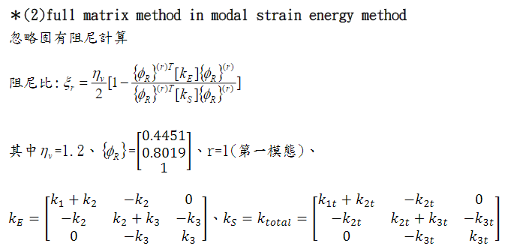

$$ξ_{r}=0.03305622$$

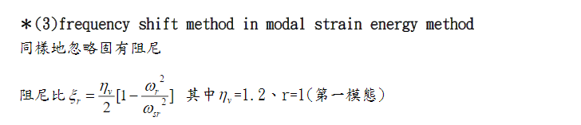

$$ω_{r}^{2} and ω_{sr}^{2} use eignvalue get (np.linalg.eig in python)$$

$$ξ_{r}=0.03339896823005983$$

import math

import matplotlib.pyplot as plt

import numpy as np

n = 2 *# 看不懂*

cos = 4 / 5

area = 0.09 * 0.11 *# m2*

thickness = 0.024 *# m*

mass = 10 * 9.81 * 1e6 *# kN*

T = 32 *# c*

G_1 = math.exp(10.17433) * (T ** (-3.10205)) * 1.34840758 * 1e6 *# N / m2*

eta_v = 1.2

kd = G_1 * area / thickness * n

kv = kd * (cos ** 2)

k_1 = 7e6 *# N / m*

k_2 = 6.6e6 *# N / m*

k_3 = 7e6 *# N / m*

k_1t = k_1 + kv

k_2t = k_2 + kv

k_3t = k_3 + kv

k_total = np.mat([[k_1t + k_2t, -k_2t, 0],

[-k_2t, k_3t + k_2t, -k_3t],

[0, -k_3t, k_3t]])

print(k_total)

k_e = np.mat([[k_1 + k_2, -k_2, 0],

[-k_2, k_3 + k_2, -k_3],

[0, -k_3, k_3]])

phi = np.mat([[0.4451],

[0.8019],

[1]])

r = 1

k_s = k_total

phi_r = np.power(phi, r)

xi_r = eta_v / 2 * (1 -

(np.transpose(phi_r) * k_e * (phi_r)) /

(np.transpose(phi_r) * k_s * (phi_r)))

print(xi_r)

omega_r_squre = np.linalg.eig(k_e)[0][0] / mass

omega_sr_squre = np.linalg.eig(k_s)[0][0] / mass

xi_r = eta_v / 2 * (1 - omega_r_squre / omega_sr_squre)

print(xi_r)

HW5_3

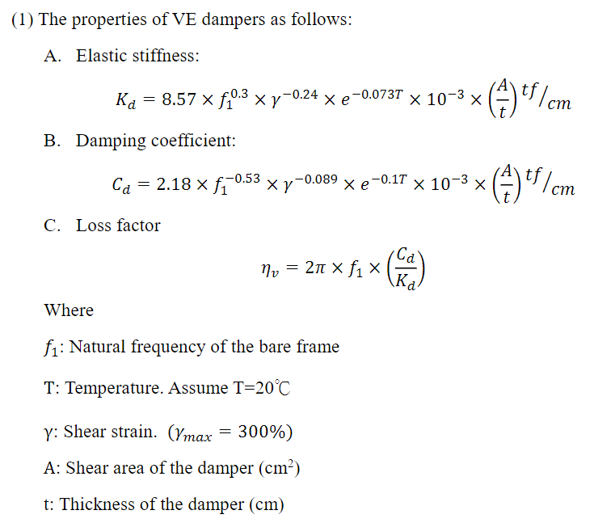

Try and error to get Kd Cd and $η_{v}$

Result:

Kd: 2958.8310418740784

Cd: 205.77600079596348

$η_{v}$: 1.3281848637356404

$ξ_{r}$: 0.20023210659258528 = 20.02%







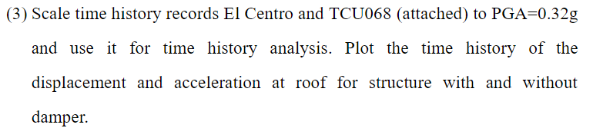

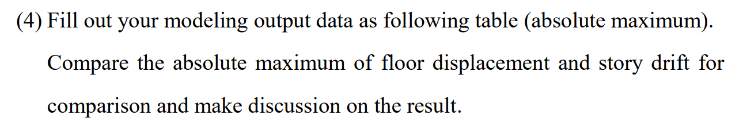





Discuss

1. VE damper 對於位移速度加速度都有很好的抑制效果
2. Story drift 也都下降很多。
3. 不同的地震也會影響效果，像是 TCU068 EW 向，對於加速度的效果就沒有位移速度的顯著。TCU068 NS 向，反而是對速度效果最差。El Centro 則對速度影響最好。

import math

*# step 1*

A_over_t = 3.05 / 0.022

*# step 2*

period_s = 0.2792

fs_1 = 1 / period_s

f_1 = 1 / 0.3290 *# HZ*

T = 20 *# c*

gamma = 3

xi_c = 0.02

k_d = 8.57 * (f_1 ** 0.3) * (gamma ** (-0.24)) * \

math.exp(-0.073 * T) * 1e1 * (A_over_t) *# tf / m*

c_d = 2.18 * (f_1 ** (-0.53)) * (gamma ** (-0.089)) * \

math.exp(-0.1 * T) * 1e1 * (A_over_t) *# tf / m*

eta_v = 2 * math.pi * f_1 * c_d / k_d

omega_r_square = (2 * math.pi * f_1) ** 2

omega_sr_square = (2 * math.pi * fs_1) ** 2

xi_r = xi_c + (eta_v - 2 * xi_c) / 2 * (1 - omega_r_square / omega_sr_square)

print('Step 1')

print('Kd:', k_d)

print('Cd:', c_d)

print('eta_v:', eta_v)

print('')

print('Step 2')

print('xi_r:', xi_r)

print('')

clc; clear; close all;

El_Centro_EW = filename_to_array('El Centro_EW(200Hz)', 1, 1, 0);

*% TCU068_Z = filename_to_array('TCU068', 4, 2, 11);*

TCU068_NS = filename_to_array('TCU068', 4, 3, 11);

TCU068_EW = filename_to_array('TCU068', 4, 4, 11);

El_Centro_EW_normalize = El_Centro_EW / max(El_Centro_EW) * 0.32;

TCU068_NS_normalize = TCU068_NS / max(TCU068_NS) * 0.32;

TCU068_EW_normalize = TCU068_EW / max(TCU068_EW) * 0.32;

fileID = fopen('El_Centro.txt', 'w');

fprintf(fileID, '%f\n', El_Centro_EW_normalize);

fclose(fileID);

fileID = fopen('TCU068_NS.txt', 'w');

fprintf(fileID, '%f\n', TCU068_NS_normalize);

fclose(fileID);

fileID = fopen('TCU068_EW.txt', 'w');

fprintf(fileID, '%f\n', TCU068_EW_normalize);

fclose(fileID);

clc; clear; close all;

plot_timehistory('El_Centro_RF', 'El Centro')

plot_timehistory('TCU068_EW_RF', 'TCU068 EW')

plot_timehistory('TCU068_NS_RF', 'TCU068 NS')

function [] = plot_timehistory(*filename*, *titlename*)

period = filename_to_array(filename, 3, 1, 10);

acceleration = filename_to_array(filename, 3, 2, 10);

displacement = filename_to_array(filename, 3, 3, 10);

acceleration_nodamper = filename_to_array((filename + "_nodamper"), 3, 2, 10);

displacement_nodamper = filename_to_array((filename + "_nodamper"), 3, 3, 10);

figure;

plot(period, acceleration_nodamper, period, acceleration);

title([titlename ' Roof absolute acceleration']);

xlabel('Time(sec)');

ylabel('acceleration(m/s^2)');

legend({'without damper', 'with damper'}, 'Location', 'northeast');

figure;

plot(period, displacement_nodamper, period, displacement);

title([titlename ' Roof relative displacement']);

xlabel('Time(sec)');

ylabel('displacement(m)');

legend({'without damper', 'with damper'}, 'Location', 'northeast');

end

function [] = ignore_headlines(*fileID*, *headlines*)

*%*

*% 忽略標題.*

*%*

*% @since 1.0.0*

*% @param {number} [fileID] fileID.*

*% @param {number} [headlines] 要忽略的行數.*

*%*

for index = 1 : headlines

fgetl(fileID);

end

end

function *data* = filename_to_array(*filename*, *total_col*, *array_col*, *headlines*)

*%*

*% 適用於被動控制給的 file_input.*

*%*

*% @since 3.0.0*

*% @param {string} [filename] 檔案名稱.*

*% @param {number} [total_col] 總共有幾欄.*

*% @param {number} [array_col] 要回傳第幾欄.*

*% @param {number} [headlines] 忽略標題.*

*% @return {array} [data] 加速度歷時資料.*

*% @see ignore_headlines*

*%*

fileID = fopen((filename + ".txt"), 'r');

ignore_headlines(fileID, headlines);

repeat_f = repmat('%f', 1, total_col);

A = fscanf(fileID, repeat_f, [total_col Inf]).';

fclose(fileID);

data = A(:, array_col);

end

clc; clear; close all;

generate_max('El_Centro_ALL')

generate_max('TCU068_EW_ALL')

generate_max('TCU068_NS_ALL')

function [] = generate_max(*filename*)

A_2F = filename_to_array(filename, 10, 2, 17) * 100;

V_2F = filename_to_array(filename, 10, 3, 17) * 100;

D_2F = filename_to_array(filename, 10, 4, 17) * 100;

A_3F = filename_to_array(filename, 10, 5, 17) * 100;

V_3F = filename_to_array(filename, 10, 6, 17) * 100;

D_3F = filename_to_array(filename, 10, 7, 17) * 100;

A_RF = filename_to_array(filename, 10, 8, 17) * 100;

V_RF = filename_to_array(filename, 10, 9, 17) * 100;

D_RF = filename_to_array(filename, 10, 10, 17) * 100;

A_2F_nodamper = filename_to_array((filename + "_nodamper"), 10, 2, 17) * 100;

V_2F_nodamper = filename_to_array((filename + "_nodamper"), 10, 3, 17) * 100;

D_2F_nodamper = filename_to_array((filename + "_nodamper"), 10, 4, 17) * 100;

A_3F_nodamper = filename_to_array((filename + "_nodamper"), 10, 5, 17) * 100;

V_3F_nodamper = filename_to_array((filename + "_nodamper"), 10, 6, 17) * 100;

D_3F_nodamper = filename_to_array((filename + "_nodamper"), 10, 7, 17) * 100;

A_RF_nodamper = filename_to_array((filename + "_nodamper"), 10, 8, 17) * 100;

V_RF_nodamper = filename_to_array((filename + "_nodamper"), 10, 9, 17) * 100;

D_RF_nodamper = filename_to_array((filename + "_nodamper"), 10, 10, 17) * 100;

fprintf('%.3f %.3f %.3f %.3f %.3f %.3f %.3f %.3f %.3f\n', max(D_RF_nodamper), max(V_RF_nodamper), max(A_RF_nodamper), max(D_RF), max(V_RF), max(A_RF), max(D_RF) / max(D_RF_nodamper), max(V_RF) / max(V_RF_nodamper), max(A_RF) / max(A_RF_nodamper));

fprintf('%.3f %.3f %.3f %.3f %.3f %.3f %.3f %.3f %.3f\n', max(D_3F_nodamper), max(V_3F_nodamper), max(A_3F_nodamper), max(D_3F), max(V_3F), max(A_3F), max(D_3F) / max(D_3F_nodamper), max(V_3F) / max(V_3F_nodamper), max(A_3F) / max(A_3F_nodamper));

fprintf('%.3f %.3f %.3f %.3f %.3f %.3f %.3f %.3f %.3f\n', max(D_2F_nodamper), max(V_2F_nodamper), max(A_2F_nodamper), max(D_2F), max(V_2F), max(A_2F), max(D_2F) / max(D_2F_nodamper), max(V_2F) / max(V_2F_nodamper), max(A_2F) / max(A_2F_nodamper));

end

HW5_4

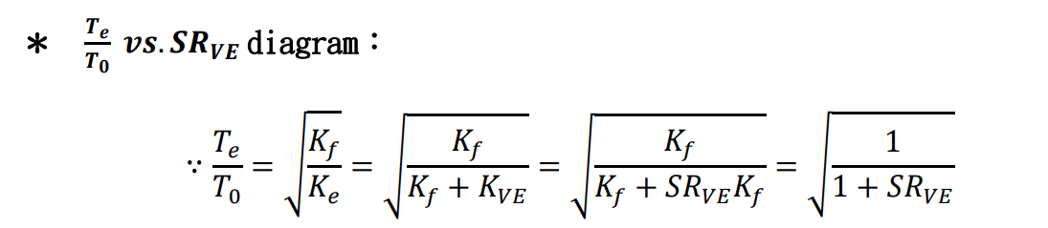



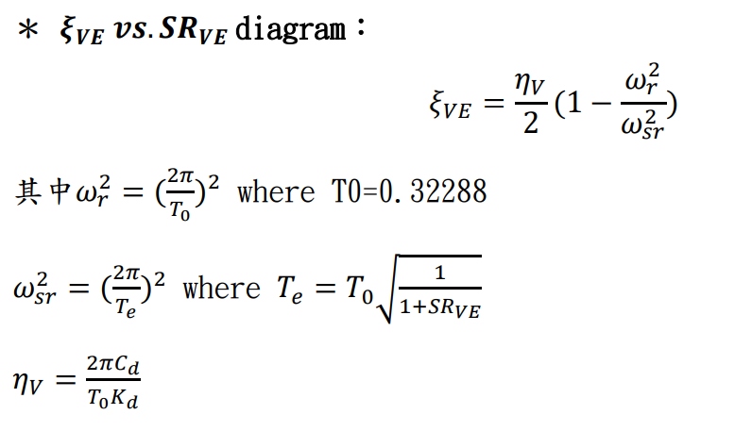

clc; clear; close all;

x = 0: 0.001 : 2;

y = sqrt(1 ./ (1 + x));

figure;

plot(x, y);

title('T_e/T_0 vs SR_V_E');

xlabel('SR_V_E');

ylabel('T_e/T_0');

period_0 = 0.3290; *% s*

mass = 3.622244; *% t*

eta_v = 1.3281848637356404;

sr_ve = 0 : 0.01 : 8;

period_e = period_0 * sqrt(1 ./ (1 + sr_ve));

omega_r = 2 * pi / period_0;

omega_sr = 2 * pi ./ period_e;

xi_ve = eta_v ./ 2 * (1 - (omega_r ^ 2) ./ (omega_sr .^ 2));

figure;

plot(sr_ve, xi_ve);

title('\xi_V_E vs SR_V_E');

xlabel('SR_V_E');

ylabel('\xi_V_E');